Lab 02
Resistors color codes and measurement of resistance.
Name: _________________________________________________________________________
Regd. No: _______________________________________________________________________
Components and wires are coded are with colors to identify their value and function.

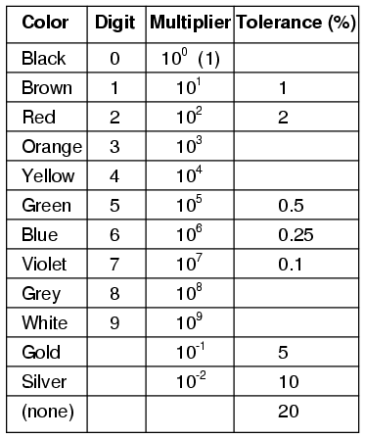

The colors brown, red, green, blue, and violet are used as tolerance codes on 5-band resistors only. All 5-band resistors use a colored tolerance band. The blank (20%) "band" is only used with the "4-band" code (3 colored bands + a blank "band").
4-Band and 5-Band Resistor Color Chart

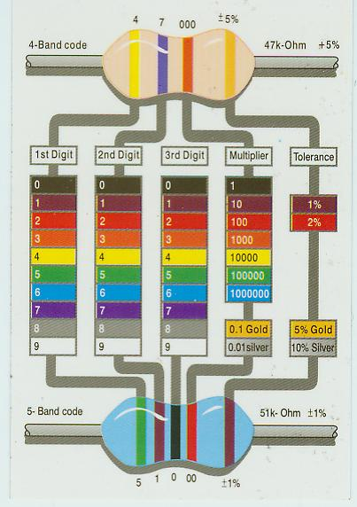
Task #1

A resistor colored Yellow-Violet-Orange-Gold

Task #2

A resistor colored Green-Red-Gold-Silver

Task #3

A resistor colored White-Violet-Black

Task#4

A resistor colored Orange-Orange-Black-Brown-Violet

Task #5

A resistor colored Brown-Green-Grey-Silver-Red

Task #6

A resistor colored Blue-Brown-Green-Silver-Blue

Resistor specified with a Resistance value can also be constructed using 4-Bands and 5-Bands of color

A resistor of 1Ω with tolerance of 5% can be designed using the following 4-Bands of color
Brown-black-gold-gold
Same resistance value can also be designed using the following 5-Bands of color
Brown -black -black-silver
Task # 7
Design Resistor with resistance of 5 Ω using 4-Bands of color

Task # 8
Design Resistor with resistance of 6.5 Ω using 4-Bands of color

Task # 9
Design Resistor with resistance of 70 Ω using 5-Bands of color

Task # 10
Design Resistor with resistance of 2.2k Ω using 5-Bands of color

Task # 11
Design Resistor with resistance of 7 MΩ using 4-Bands of color

Task # 12
Design Resistor with resistance of 10 Ω using 5-Bands of color

Task # 13
Design Resistor with resistance of 470 kΩ using 4-Bands of color

Resistor | Color 1 | Color 2 | Color 3 | Color4 | Coded Resistance | Tolerance | Measured resistance | reading error
1
2
3

Conclusion
Summarize what you have learned today (not what you have done).

Checked By:

----------------------------

